    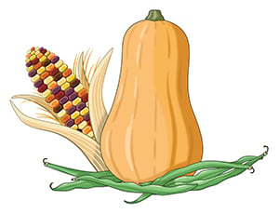 |  |  | 9:30 Coffee & Chats NL  10:00 Morning Moves MC  11:00 Bingo SL  1:30 Polish Me Lovely  3:00 Who am I? SL  4:00 Family Feud MC | 9:30 Coffee & Chats NL  10:00 Candy Land MC  11:00 Workout with Ken SL  1:30 One to One Visits  3:00 Creativity Workshop SL  4:00 Shake a Memory MC | 9:30 Coffee & Chats NL  10:00 Hearts Bloom MC  11:00 Hearts Bloom  at the Mead SL    1:30 One to One Visits  2:00 Marco Floyd MDR  3:30 Hallway Strolls MC | 9:30 Hand Massages NL/MC  10:00 Reminisce MC  11:00 Chair Exercise SL  1:30 One to One Visits  2:30 Wine and Cheese MDR    4:00 Foodie Chats MC  The Orient Express Day | 9:30 Coffee & Chats NL  10:00 One to One Visits  11:00 Beach Ball Toss MC  2:00 Movie Matinee SL  4:00 Mass CH    Golden Arches Day
9:30 Coffee & Chats NL  10:00 Stream Church MC  10:30 Polish Me Lovely  1:30 One to One Visits  2:30 Finish the Phrase SL  4:00 Sunroom Visits MC  German American Day | 9:30 Coffee & Chats NL  10:00 Short Stories MC  11:00 Chair Exercise SL  1:30 One to One Visits  2:30 Mass CH  3:30 Brain Puzzles MC  Boost Your Brain Day | 9:30 Hand Massages NL/MC  10:00 Movie Matinee MC/SL  1:30 One to One Visits  3:00 Chuck and Friends MDR  4:00 This or That MC   |  | 8:00 Breakfast with the xxxxxBishop (offsite)  9:30 Coffee and Chats  11:00 Guess the Song SL  1:30 One to One Visits  2:30 Food Forum MDR  3:30 Hallway Strolls MC | 9:30 Coffee & Chats NL  10:00 Hearts Bloom MC  11:00 Hearts Bloom  at the Mead SL  1:30 One to One Visits  3:00 Sing with Marie MDR  4:00 Puzzles with Friends MC | 9:30 Coffee & Chats NL  10:00 Church of The xxxxxxTransfiguration CH  11:00 Chair Exercise SL  1:30 One to One Visits  2:30 Sing-A-Long SL  3:30 Build a Grocery List MC | 9:30 Coffee & Chats NL  10:00 Movie Matinee MC  10:30 Polish Me Lovely  1:30 Pet Parade & Blessing    3:00 Autumn Craft SL  4:00 Mass CH
9:30 Coffee & Chats NL  10:00 Stream Church MC  11:00 This or That SL  1:30 One to One Visits  2:30 Puzzles w/Friends SL  Detroit Lions vs. Dallas Cowboys at 4:25PM  Clergy Appreciation Day | 9:30 Coffee & Chats NL  10:00 Have a Ball MC  11:00 Chair Exercise SL  1:30 One to One Visits  2:30 Mass CH  3:30 Penny Ante MC | 9:30 Coffee & Chats NL  10:00 Music with Julie MC  11:00 Devotions w/Shella SL  1:30 One to One Visits  2:30 Culinary Corner MDR  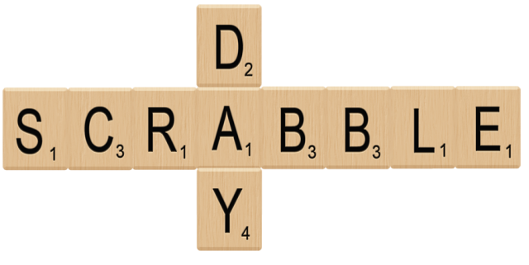  3:30 Team Scrabble SL |  | 9:30 Coffee & Chats NL  10:00 Balloon Volley MC  11:00 Workout with Ken SL  1:30 One to One Visits  3:00 Creativity Workshop SL  4:00 Coloring w/Friends MC  Fall Harvest Day  Bosses Day | 9:30 Coffee & Chats NL  10:00 Hearts Bloom MC  11:00 Hearts Bloom  at the Mead SL  1:30 One to One Visits  2:30 Family Feud SL  3:30 Spelling Bee MC | 9:30 Coffee & Chats NL  10:00 Rhyme Time MC  11:00 Chair Exercise SL  1:30 One to One Visits  2:30 Oktoberfest  with Helmut Kolke MDR  4:00 Hallway Strolls MC   | 9:30 Coffee & Chats NL  10:00 One to One Visits  11:00 Bingo MC  2:00 Movie Matinee SL  4:00 Mass CH    Sweetest Day
9:30 Coffee & Chats NL  10:00 Stream Church MC  11:00 Left-Right-Center SL  1:30 One to One Visits  3:00 Word of Faith CH  Detroit Lions vs. Minnesota Vikings at 1:00 PM | 9:30 Coffee & Chats NL  10:00 Beach Ball Toss MC  11:00 Air Hockey SL  1:30 One to One Visits  2:30 Mass CH  3:30 Table Talk & Snack MC | 9:30 Hand Massages NL/MC  10:30 Ladies Nail Spa  1:30 One to One Visits  3:00 Chuck and Friends MC  4:00 Foodie Chats MC |  | 9:30 Coffee & Chats NL  10:00 This or That MC  11:00 Exercise with Jen SL  1:30 One to One Visits  2:30 How Things Have xxxxxChanged SL  3:30 Prime Timers (Men) MC  A BOO-tiful! Day | 9:30 Coffee & Chats NL  10:00 Hearts Bloom MC  11:00 Hearts Bloom  at the Mead SL  1:30 One to One Visits  2:30 Penny Ante SL  3:30 Hallway Strolls MC | 9:30 Coffee & Chats NL  10:00 Coloring w/Friend s MC  11:00 Chair Exercise SL  1:30 One to One Visits  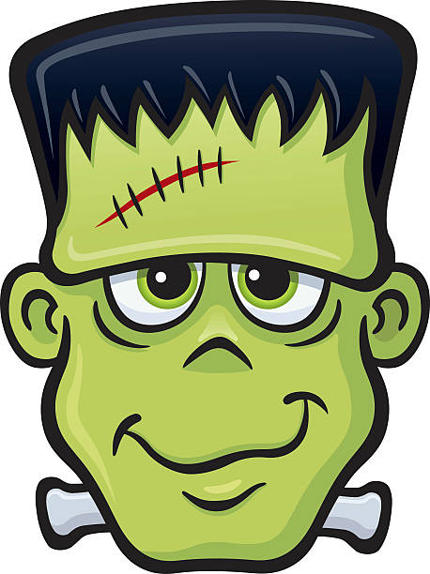  2:30 The History of xxxxxFrankenstein SL  3:30 Brain Games MC  Frankenstein Friday | 9:30 Coffee & Chats NL  10:00 One to One Visits  11:00 Candy Land MC  2:00 Trunk or Treat  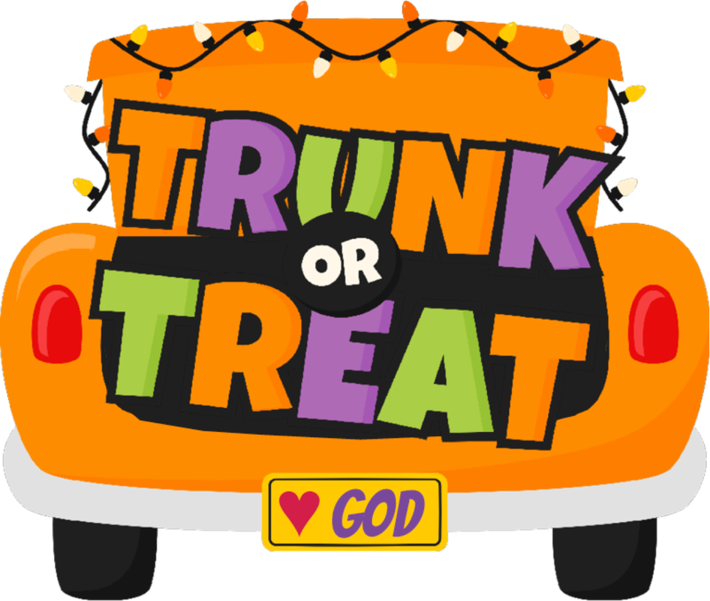  4:00 Mass CH
9:30 Coffee & Chats NL  10:00 Stream Church MC  11:00 You Be the Judge SL  1:30 One to One Visits  2:30 Puzzles w/Friends SL  Detroit Lions vs. Tennessee Titans at 1:00 PM | 9:30 Coffee & Chats NL  10:00 ABC-Favorites List MC  11:00 Chair Exercise SL  1:30 One to One Visits  2:30 Mass CH  3:30 Library Visits  St. Jude’s Day | 9:30 Coffee & Chats NL  10:00 Morning Moves MC  11:00 Bingo SL  1:30 One to One Visits  3:00 Music with Julie SL  4:00 Shake a Memory MC |  | 9:30 Coffee & Chats NL  10:00 Parachute Fun MC  11:00 Activities Meeting SL  1:30 One to One Visits  2:30 Game of Choice SL  3:30 Table Talk & Snack MC  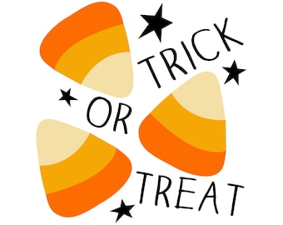  Candy Corn Day | 9:30 Coffee & Chats NL  10:00 Hearts Bloom MC  11:00 Hearts Bloom  at the Mead SL  1:30 One to One Visits  2:30 B-Day/Halloween Party  3:30 Halloween Bingo MC |   On Fridays wear Pink for  Breast Cancer Awareness!  St. Anne’s Mead  Assisted Living & Memory Care
**Scheduled activities are subject to cancellation or change.
Sunday | Monday | Tuesday | Wednesday | Thursday | Friday | Saturday
 |  | 1 | 2  Rosh Hashanah Begins | 3 | 4 | 5
6 | 7 | 8 | 9 | 10 | 11  Yom Kippur Begins | 12
13 | 14  Thanksgiving Day (Canada)  Indigenous Peoples’ Day  Columbus Day (US) | 15 | 16  Sukkot Begins | 17 | 18 | 19
20 | 21 | 22 | 23 | 24  Simchat Torah Begins | 25 | 26
27 | 28 | 29 | 30 | 31  Halloween

