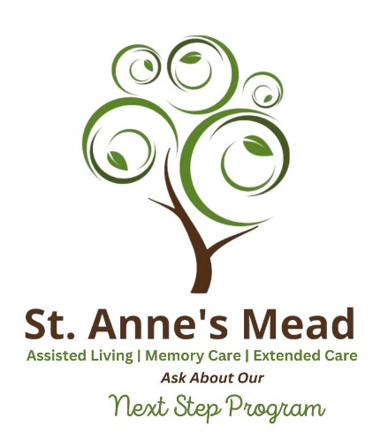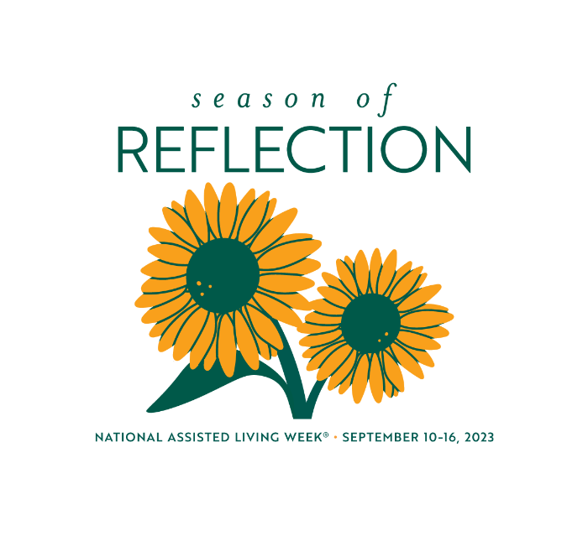
To celebrate National Assisted Living Week, we thought we’d help educate the public on what to look for when researching Assisted Living facilities. Please review our top questions and answers.
To learn more, visit saintannesmead.org (stannesmead.org) or call 248.557.1221.

#1 QUESTION:
How would you describe assisted living to people who many not know what it is?
ANSWER:
At its best, assisted living is home. “Welcome Home” is our mantra at St. Anne’s Mead. With a caring staff, residents have support for their activities of daily living, yet they have the freedom to visit with family and friends as much as they wish.
#2 QUESTION:
ANSWER, what is the number one question people should ask about an assisted living facility?
ANSWER:
Are they licensed? If they are licensed like St. Anne’s Mead is, they are inspected regularly by the State of Michigan and follow a series of protocols to keep residents safe. But the most important thing to look for is are the staff happy and engaged.
#3 QUESTION:
ANSWER, what about staffing an assisted living facility. And are there staff on-site 24 hours per day?
ANSWER:
That is very important. St. Anne’s Mead has teams of nurses and resident aides that work morning, afternoon, and overnight to ensure the health, wellness, and happiness of our residents. We also have a medical director, Dr. Somil Gupta, and on-site physical and occupational therapy.

#4 QUESTION:
What are some of the examples of the care provided?
ANSWER:
Depending on the level of care needed, St. Anne’s Mead has a full continuum of care. From Respite (or short-term) Care to Assisted Living, Extended Care, Hospice Care and Memory Care. This makes it possible for residents to move from one area to the next as their care needs change, and they don’t have to move from the home they know and trust.
#5 QUESTION:
What is included in the monthly Assisted Living Fee?
ANSWER:
St. Anne’s Mead offers an Essential Package in Assisted Living that includes rent, utilities, nutritious meals and snacks, life enrichment activities, housekeeping and a Lifeline Pendant. Fees vary from place to place so look for the facility that offers the greatest value and has a reputation for high quality care.
#6 QUESTION:
How do you foster a sense of community for assisted living residents?
ANSWER:
At St. Anne’s Mead, we learn about our residents’ stories even before they first arrive. We learn their interests, backgrounds, dietary needs, and what activities make them happy. Residents have a bill of rights. We instill in them that St. Anne’s Mead is their home. We help integrate them into key activities and introduce them to other residents they may enjoy dining with.
#7 QUESTION:
Do you offer programs to help residents with dementia including Alzheimer’s disease?
ANSWER:
Yes. Due to the growing need for memory care, St. Anne’s Mead opened a dedicated memory care home in 2018. It is adjacent to assisted living, and some of our assisted living residents have moved to memory care if their dementia progresses to the level where they need it. We have trained our staff in the internationally renowned “Best Friends” approach to memory care, which simply means socialization is the best therapy for people living with dementia.
#8 QUESTION:
What about activities? What should people look for?
ANSWER:
Look for a full calendar of activities that are educational, therapeutic, and fun. One of the greatest assets of St. Anne’s Mead is our hospitality team and we take our residents on culinary adventures regularly. We offer exercise classes, music, art and pet therapy, computer classes, lectures, games and comedy, regular birthday celebrations, and walking paths and outdoor activities, weather permitting. We also offer religious services, for those who would like to participate in them.

